VERIFICATION DETAILS

NAME OF THE REGION: | EASTERN REGION
SUB-REGION: | KAMULI
Name of Local Government | KAMULI DISTRICT
VERIFIER PARTICULARS
Full name | NAMUGANGA SHARYPHA
Contact/ email and Telephone | 0782 619901
Supervisor/ Sub team leader
Name

Contact
Date of submission

HEALTH CENTRES
INFORMANT INTERVIEW/DISCUSSION GUIDE (INCHARGE OR RESPONSIBLE PERSON)

Name of Health Centre: Bukungu Health Center III

1a | Does the Facility have a record of all assets provided under UgIFT?  (Obtain a record and verify if it has the costs and numbers supplied | Record has only quantity and no costs
1b | If Not ask how many were supplied and when.

2 | How does this facility Maintain (repair/service/replace) the assets provided under Ugift

3 | Does the facility take regular record about functionality/ or breakdown of the assets provided? | No

4 | How has the UgIFT support helped in service delivery in the area, any issues, challenges and any recommendations for better program implementation.

PROCEED TO VERIFICATION AFTER THIS DISCUSSION

Health centre checklist

NAME OF LG……Kamuli District…………………………………… NAME OF HEALTH FACILITY…………Bukungu HC III………………………………………………

Equipment/ Item | Department | Asset Number | Item  Description | Life in Months | Tag Number ( engrave no.) | Date Of Purchase | Date Placed In Service | Recoverable cost | Cost | Acc Dep Cost | Net Book Value | Ytd Deprn | Equipment status | Remarks
B.P. Machine, Digital | Health |  |  |  |  |  | 15/11/2025 |  |  |  |  |  |  | Received 2. Indicated on the delivery note but not seen at the facility
B.P. Machine (Aneroid wall mounted) | Health |  |  |  |  |  | 15/11/2025 |  |  |  |  |  |  | Received 2. Indicated on the delivery note but not seen at the facility
Autoclave 20 Liters.,Duo Operated | Health |  |  |  |  |  | 15/11/2025 |  |  |  |  |  |  | Received 1
Bowl, Kick | Health |  |  |  |  |  | 15/11/2025 |  |  |  |  |  | Functional | Received 1
Bowl Stand | Health |  |  |  |  |  | 15/11/2025 |  |  |  |  |  | Functional | Received 3
Counting chamber Neubauer- Improved | Health |  |  |  |  |  | 15/11/2025 |  |  |  |  |  | Functional | Received 2. Indicated on the delivery note but not seen at the facility
Cupboard Steel, Lockable | Health |  |  |  |  |  | 15/11/2025 |  |  |  |  |  | Functional | Received 1
Drip Stand
ESR Stand | Health |  |  |  |  |  | 15/11/2025 |  |  |  |  |  | Functional | Received 1
Examination Couch
Examination light,LED | Health |  |  |  |  |  | 15/11/2025 |  |  |  |  |  | Functional | Received 2
Glucometer | Health |  |  |  |  |  | 15/11/2025 |  |  |  |  |  | Functional | Received 3
Haemoglobin Meter, Digital
Height Meter | Health |  |  |  |  |  | 15/11/2025 |  |  |  |  |  | Functional | Received 1
Instrument Trolley | Health |  |  |  |  |  | 15/11/2025 |  |  |  |  |  | Functional | Received 2
Microscope Binocular
 |  |  |  |  |  |  | 15/11/2025
Otoscope | Health |  |  |  |  |  | 15/11/2025 |  |  |  |  | Functional |  | Not indicated on the delivery note. However, the in-charge has 1 in store
Patient Screen | Health |  |  |  |  |  | 15/11/2025 |  |  |  |  | Functional |  | Received 4
Patient Trolley | Health |  |  |  |  |  | 15/11/2025 |  |  |  |  | Functional |  | Received 1
Refrigerator, Basic | Health |  |  |  |  |  | 15/11/2025 |  |  |  |  | Functional |  | Received 1
Stethoscope | Health |  |  |  |  |  | 15/11/2025 |  |  |  |  |  |  | Delivery note indicates 4 while the in-charge has 7 in store
Stop Watch | Health |  |  |  |  |  | 15/11/2025 |  |  |  |  |  | Functional | Received 2
Stretcher | Health |  |  |  |  |  | 15/11/2025 |  |  |  |  |  | Functional | Received 1
Stove, Gas | Health |  |  |  |  |  | 15/11/2025 |  |  |  |  |  |  | Received 1. The stov cant be used because gas wasn’t provided.
Weighing Scale with Height Meter, Adult | Health |  |  |  |  |  | 15/11/2025 |  |  |  |  |  | Functional | Received 2
Weighing Scale, Infant | Health |  |  |  |  |  | 15/11/2025 |  |  |  |  |  | Functional | Received 2
Weighing Scale, Toddler | Health |  |  |  |  |  | 15/11/2025 |  |  |  |  |  |  | Received 2
Wheel Chair | Health |  |  |  |  |  | 15/11/2025 |  |  |  |  |  |  | Received 2
Audio Visual Equipment
Medical Waste Bin | Health |  |  |  |  |  | 15/11/2025 |  |  |  |  |  | Functional | Received 3
Wall Clock | Health |  |  |  |  |  | 15/11/2025 |  |  |  |  |  | Functional | Received 4
Diagnostic Equipment Set for MCH
Diagnostic Equipment Set for OPD | Health |  |  |  |  |  | 15/11/2025 |  |  |  |  |  | Functional | Received 2
Glassware Set, Laboratory, Basic | Health |  |  |  |  |  | 15/11/2025 |  |  |  |  |  |  | Received 2
Hollow Ware Set, Treatment | Health |  |  |  |  |  | 15/11/2025 |  |  |  |  |  |  | Received 1
Instrument Set, Dressing | Health |  |  |  |  |  | 15/11/2025 |  |  |  |  |  | In store | Received 2
Instrument Set, Basic ENT | Health |  |  |  |  |  | 15/11/2025 |  |  |  |  |  | In store | Received 2
Instrument Set, Suture
Pulse Oximeter, Hand held | Health |  |  |  |  |  | 15/11/2025 |  |  |  |  |  | In store | Received 2
Bed, Adult Patient with Mattress | Health |  |  |  |  |  | 15/11/2025 |  |  |  |  |  | Functional | Received 10
Bed, Pediatric Patient, With Mattress | Health |  |  |  |  |  | 15/11/2025 |  |  |  |  |  | Functional | Received 4
Bedside Locker
Cupboard, Instrument | Health |  |  |  |  |  | 15/11/2025 |  |  |  |  |  | Functional | Received 1
Delivery Bed, Hydraulic Manual
Oxygen Therapy Apparatus, Mininum 45L cylinder
Resuscitator Manual, Infant, with all Mask sizes | Health |  |  |  |  |  | 15/11/2025 |  |  |  |  |  |  | Received 2
Resuscitator Manual, Adult, with all mask sizes | Health |  |  |  |  |  | 15/11/2025 |  |  |  |  |  | In store | Received 2
Suction Apparatus, (Electric) | Health |  |  |  |  |  | 15/11/2025 |  |  |  |  |  | In store | Received 2
Nebulizer, Ultrasonic | Health |  |  |  |  |  | 15/11/2025 |  |  |  |  |  | Still in store | Received 1
Oxygen Concentrator, Duo Flow | Health |  |  |  |  |  | 15/11/2025 |  |  |  |  |  | Still in store | Received 2.
Bench | Health |  |  |  |  |  | 15/11/2025 |  |  |  |  |  | Functional | Received 4.
Disinfection Buckets
Baby Cot
Diagnostic Equipment Set for Ward |  |  |  |  |  |  |  |  |  |  |  |  | Functional
Hollow Ware Set, Ward | Health |  |  |  |  |  | 15/11/2025 |  |  |  |  |  | Functional | Received 1
Instrument Set, Delivery | Health |  |  |  |  |  | 15/11/2025 |  |  |  |  |  | Functional | Received 3
Instrument Set, Stitch Removing
MVA Kit | Health |  |  |  |  |  | 15/11/2025 |  |  |  |  |  | Functional | Received 2
Stool, Laboratory | Health |  |  |  |  |  | 15/11/2025 |  |  |  |  |  | Functional | Received 1
Penguin Sucker | Health |  |  |  |  |  | 15/11/2025 |  |  |  |  |  | Functional | Received 3
Fetoscope, Dopplar | Health |  |  |  |  |  | 15/11/2025 |  |  |  |  |  | Still in store | Received 2
Bubble CPAP | Health |  |  |  |  |  | 15/11/2025 |  |  |  |  |  | Functional | Received 2
Centrifuge (Electric) | Health |  |  |  |  |  | 15/11/2025 |  |  |  |  |  | Still in store | Received 1
Kangaroo Mother Care Chair | Health |  |  |  |  |  | 15/11/2025 |  |  |  |  |  | Functional | Received 1
Radiant Infant Warmer
Haemoglobin Meter, Sahli
Delivery Bed
Examination light | Health |  |  |  |  |  | 15/11/2025 |  |  |  |  |  | Functional | Received 2
Instrument set, ENT Basic for HCIII | Health |  |  |  |  |  | 15/11/2025 |  |  |  |  |  | Still In store | Received 2
Bag Valve mask (Ambu Bag), Neonatal
Incubator
Office Chair | Health |  |  |  |  |  | 15/11/2025 |  |  |  |  |  | Functional | Received 4 but 2 have their armrest broken
Desk | Health |  |  |  |  |  |  |  |  |  |  |  | Functional | Received 7 but 3 had tops missing
Filing Cabinet | Health |  |  |  |  |  | 15/11/2025 |  |  |  |  |  | Functional | Received 2
Non Residential Buildings
Residential Buildings

SCHOOL VERIFICATION CHECKLIST

BUKUNGU HEALTH CENTRE III ASSETS- PICTORIAL
No | Asset description | Photo asset
1. | The signage of Bukungu HC III | 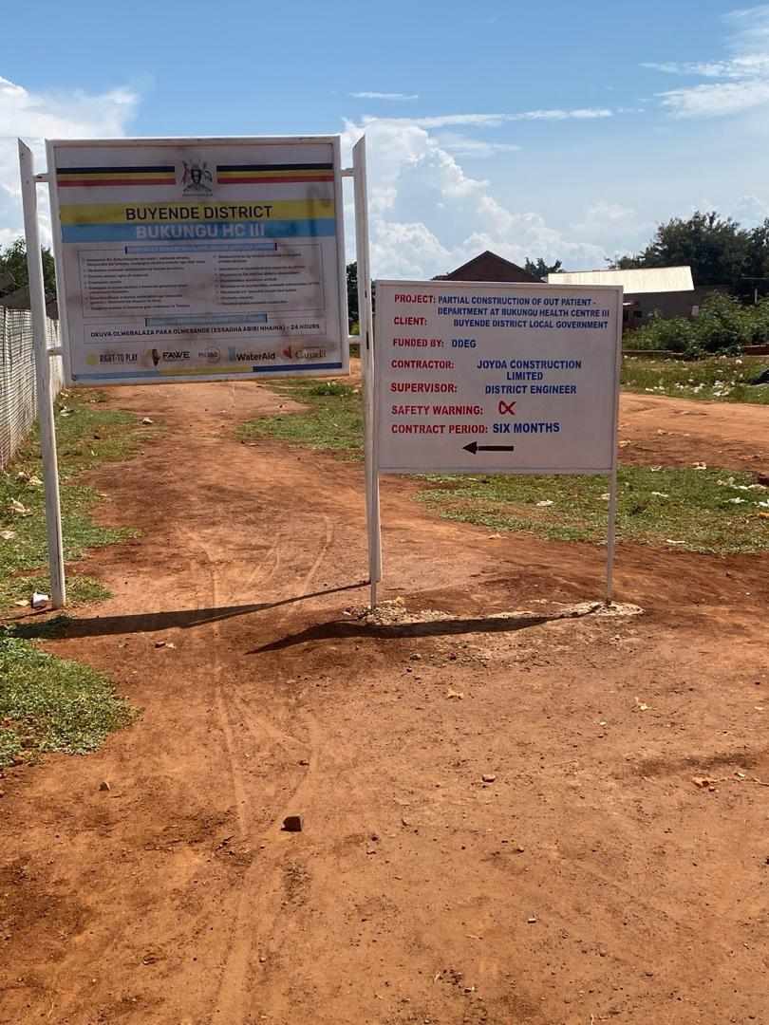
2 | The entire block housing all health Centre departments | 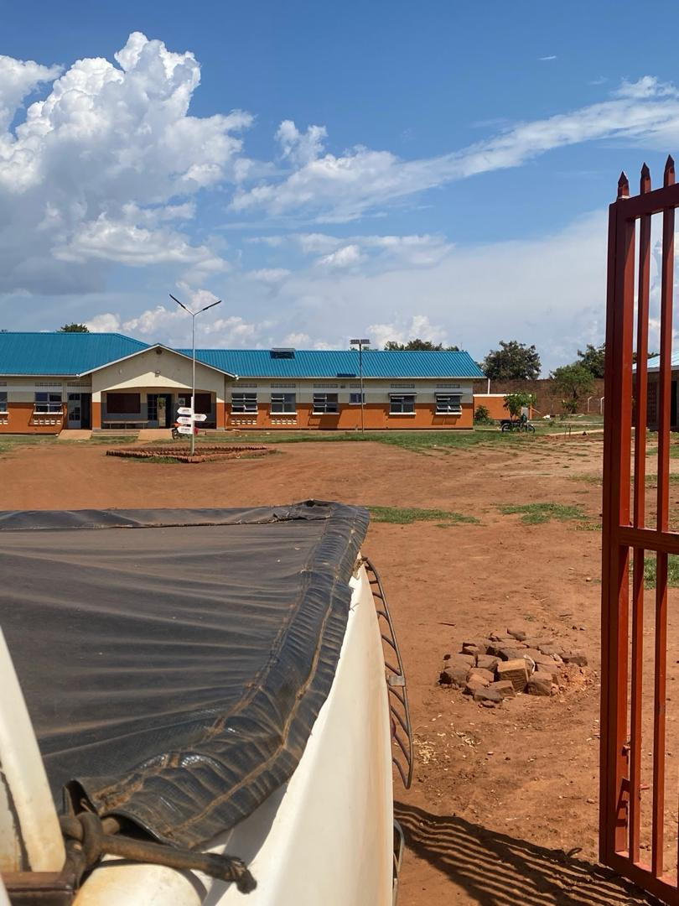
3 | The nebulizer still packed in store | 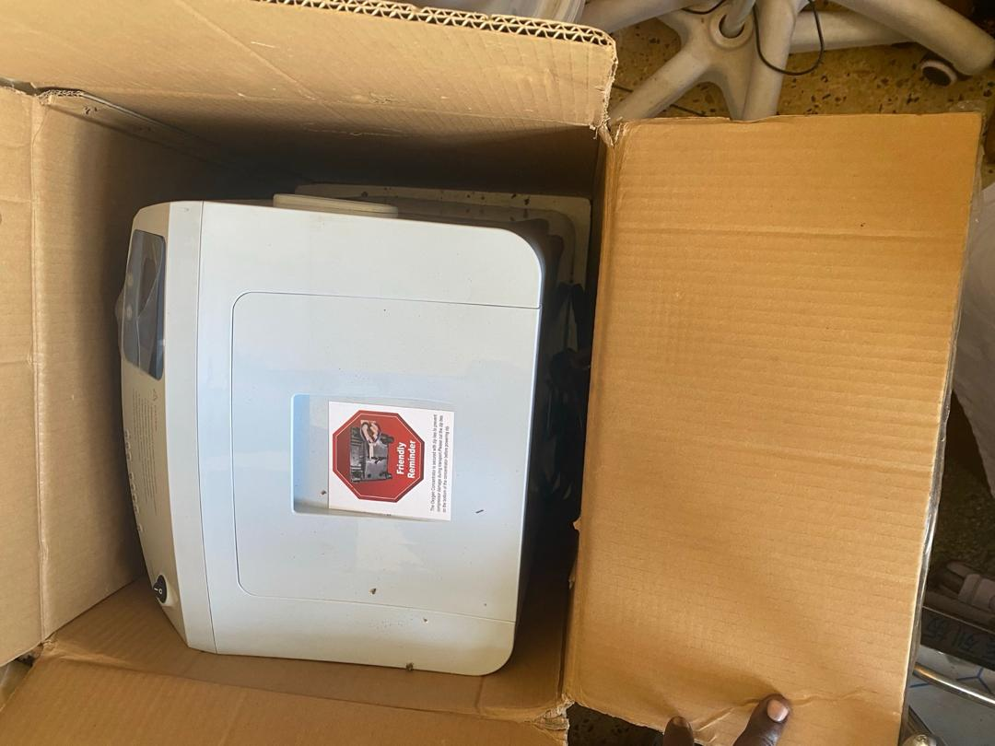
4 | The wheel chair in store | 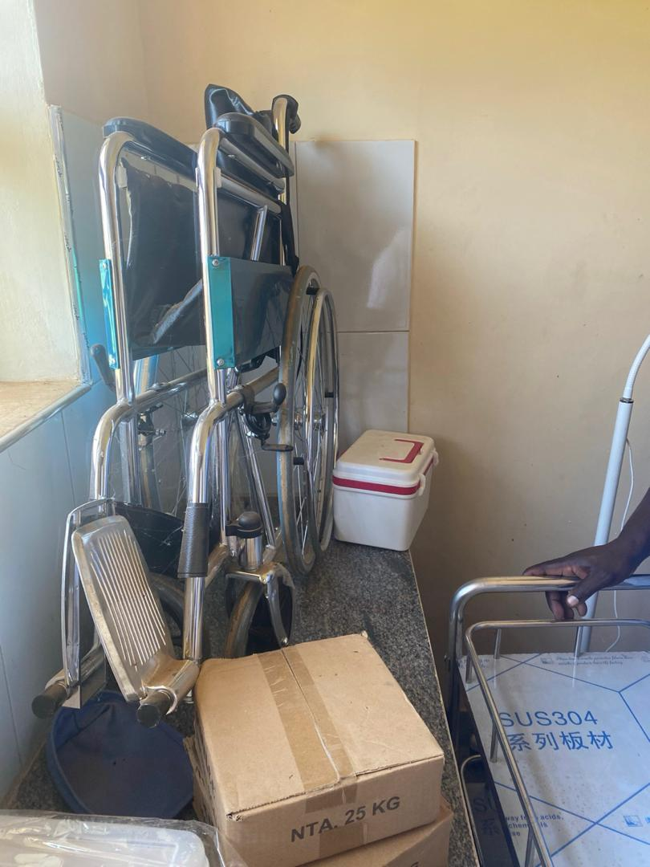
5 | A metallic 3 layered instrument trolley still in store | 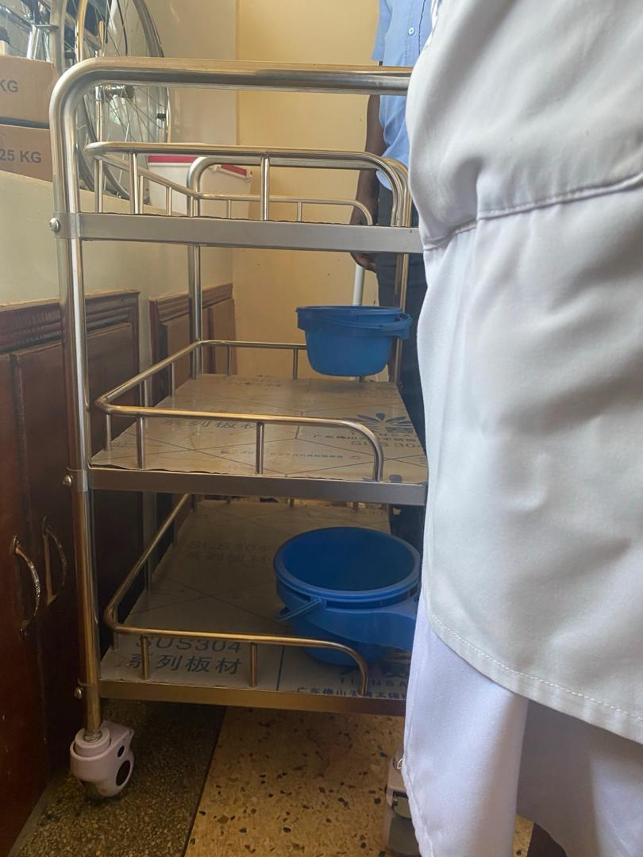
6 | Stethoscopes still in store | 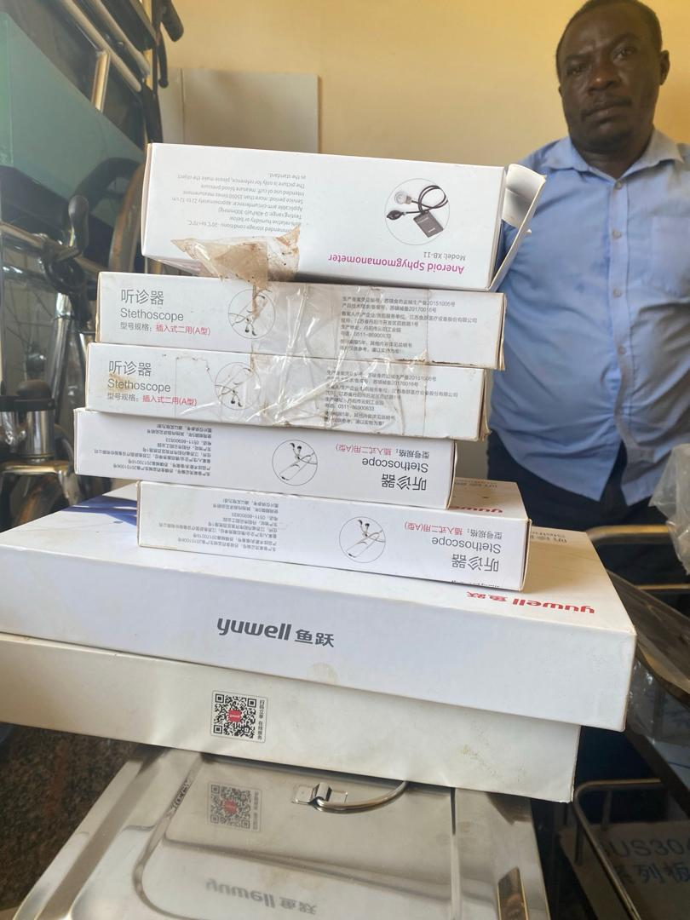
7 | A metallic autoclave still in store | 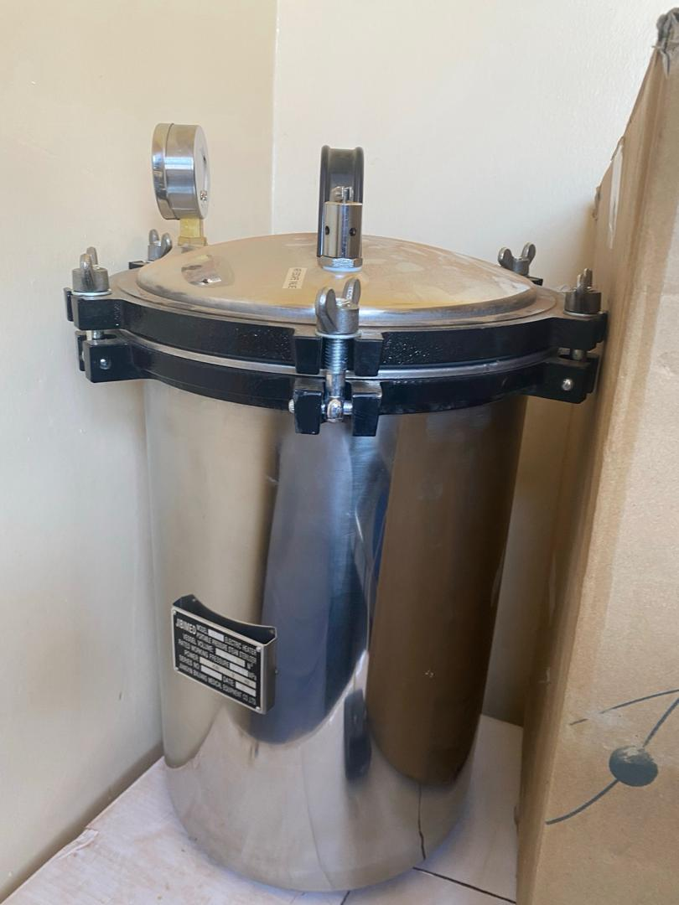
8 | Electronic examination lights not under use | 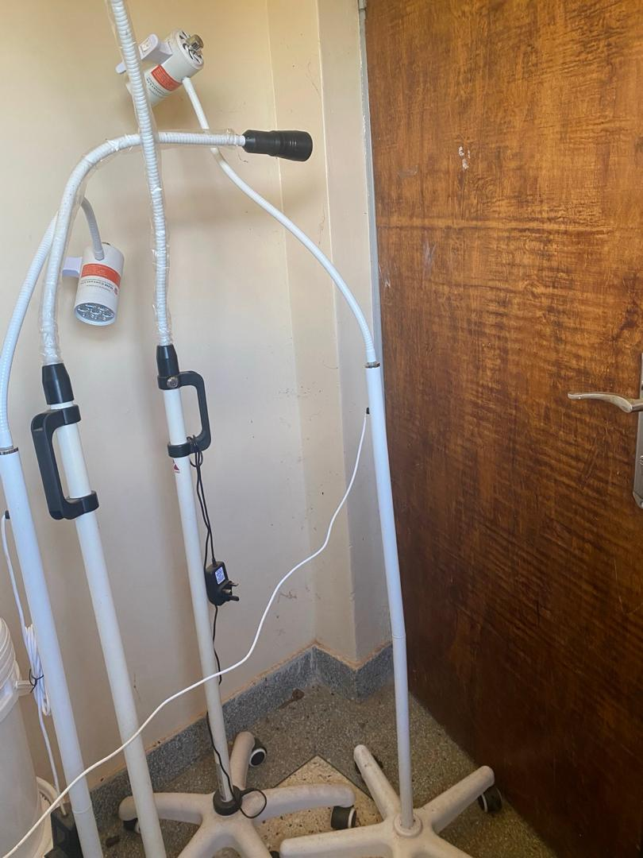
9 | Instrument set (Dressing) still in store at the facility | 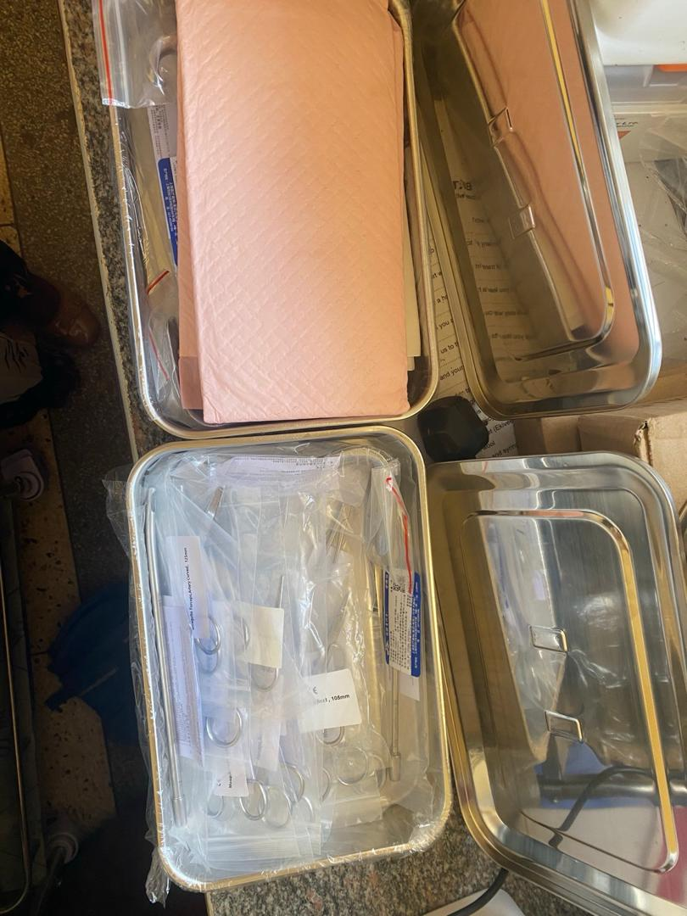
10 | Weighing scale for toddlers. Asset still in store | 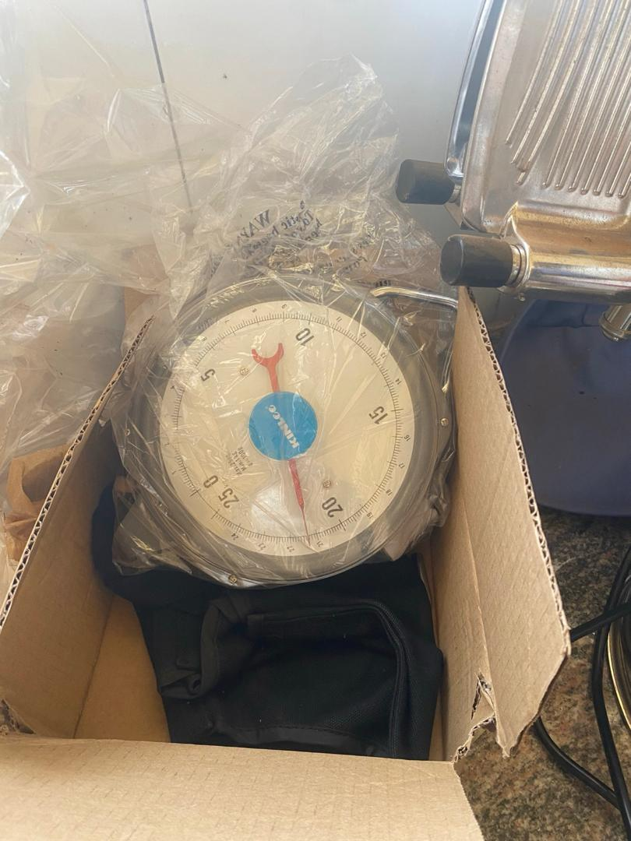
11 | Packaged otoscopes in store | 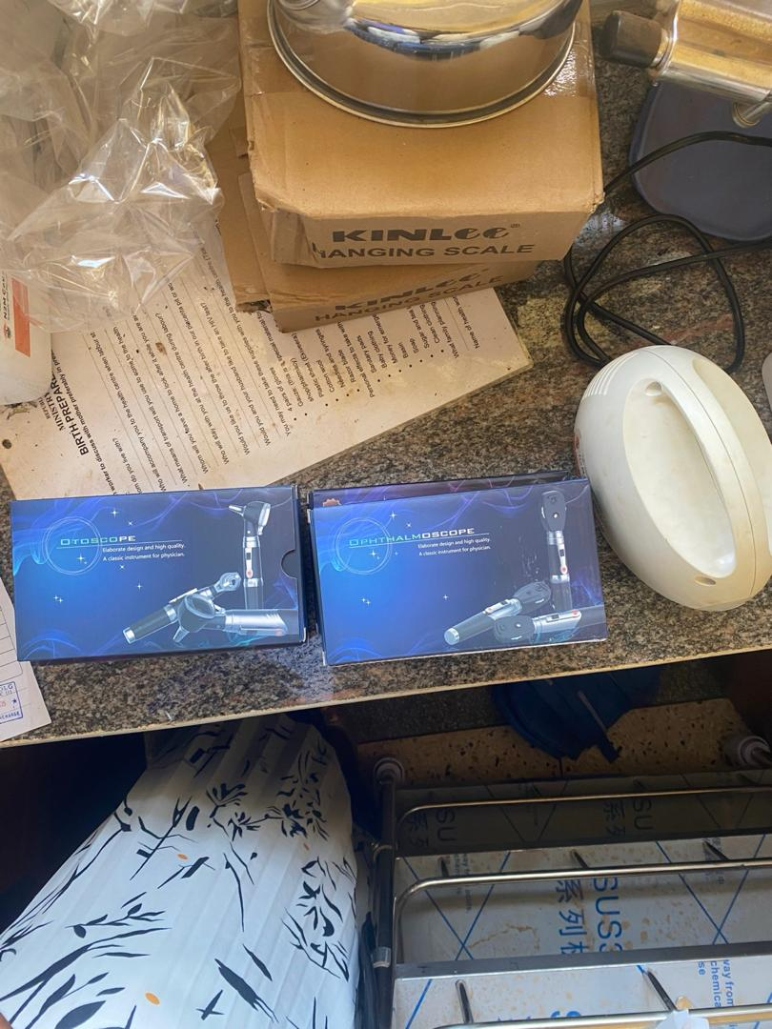
12 | An ultrasonic nebulizer and bubble CPAP still packaged in store | 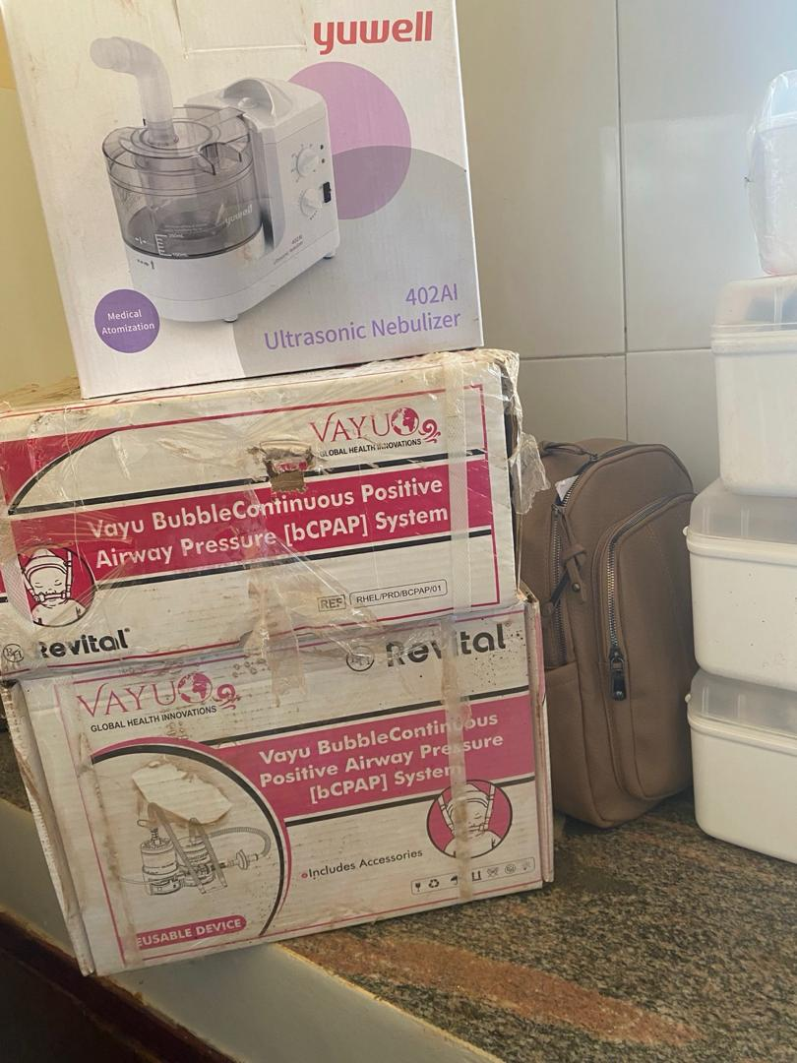
13 | An electronic suction machine still in store | 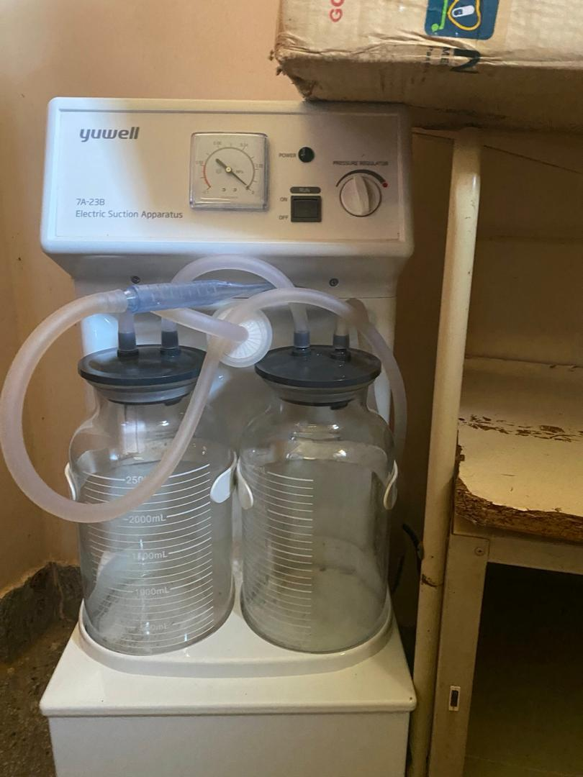
14 | Infant radiant warmer, wall clock and kangaroo chair place in the maternity ward. | 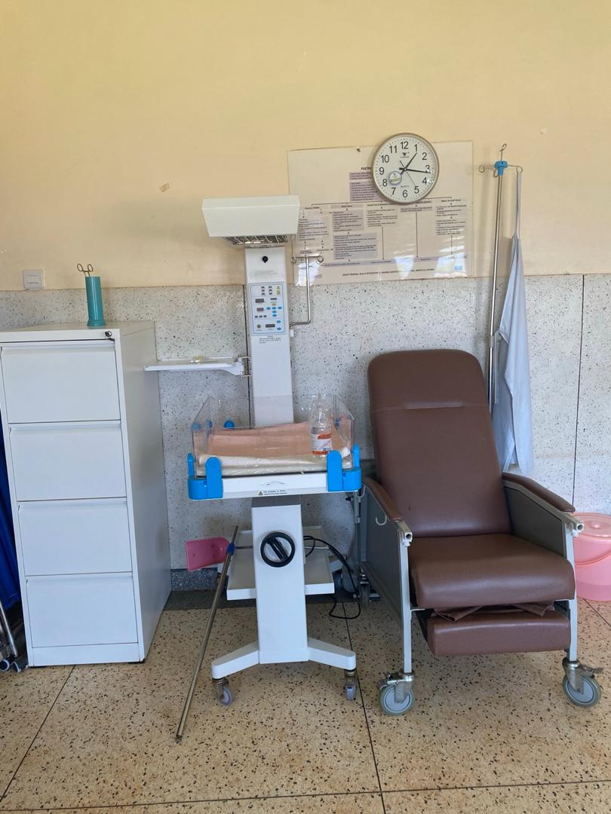
15 | A metallic bowl stand that accommodates 2 bowls at ago | 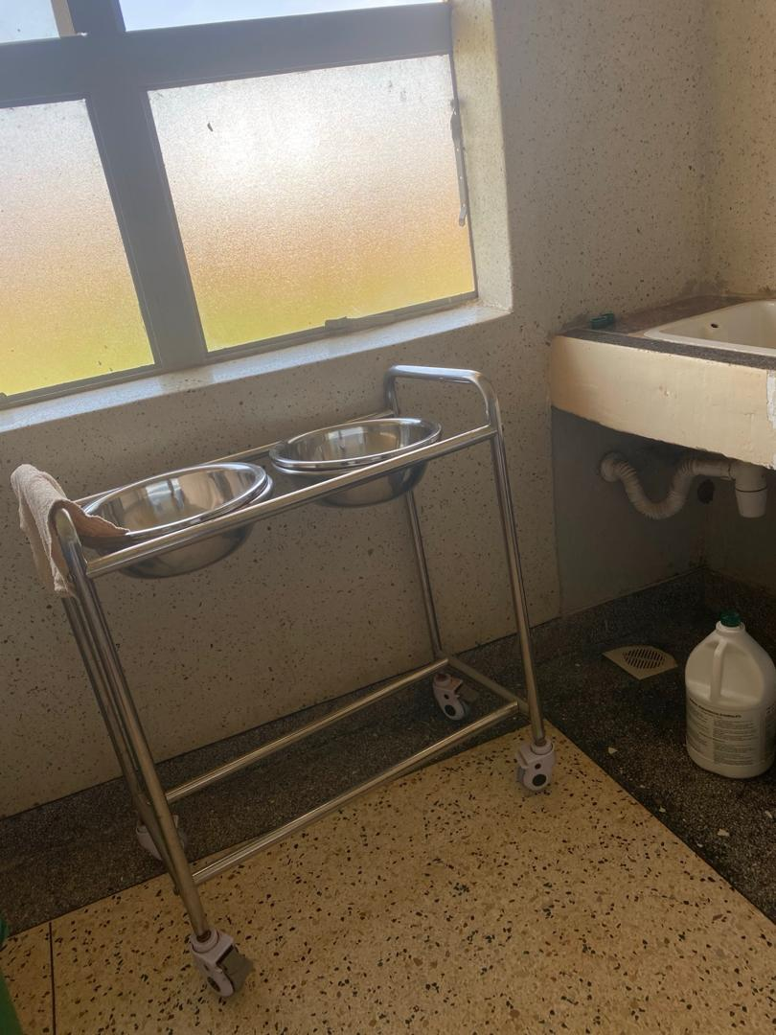
16 | Duo-flow oxygen concentrator placed in the labor suite | 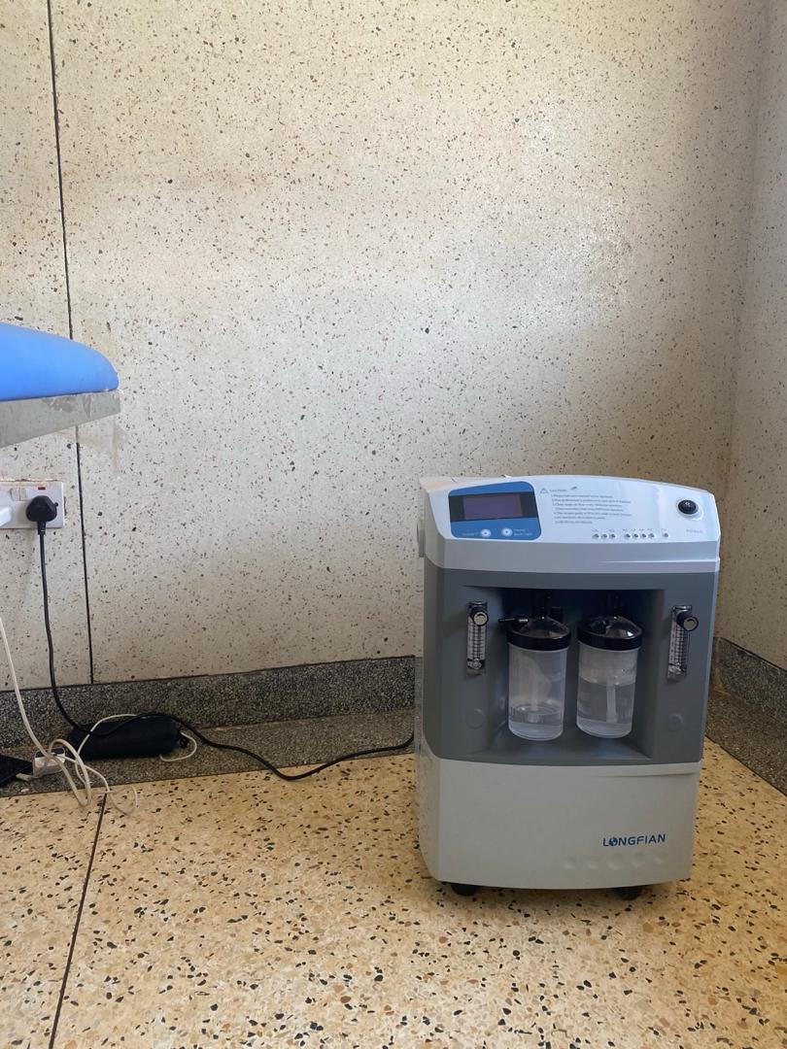
17 | An adult weighing scale with a heightmeter | 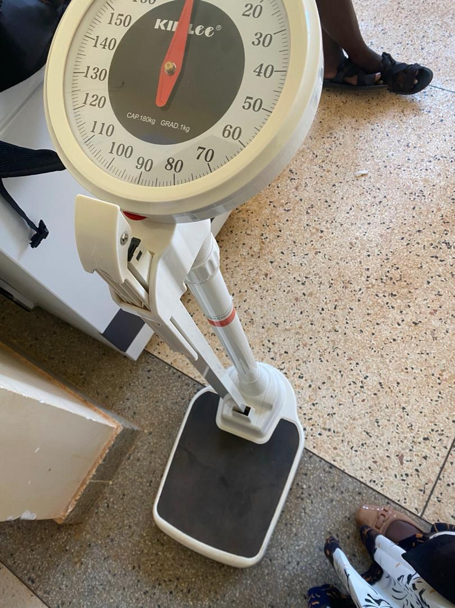
18 | Metallic disinfectant bins placed in the Adult ward | 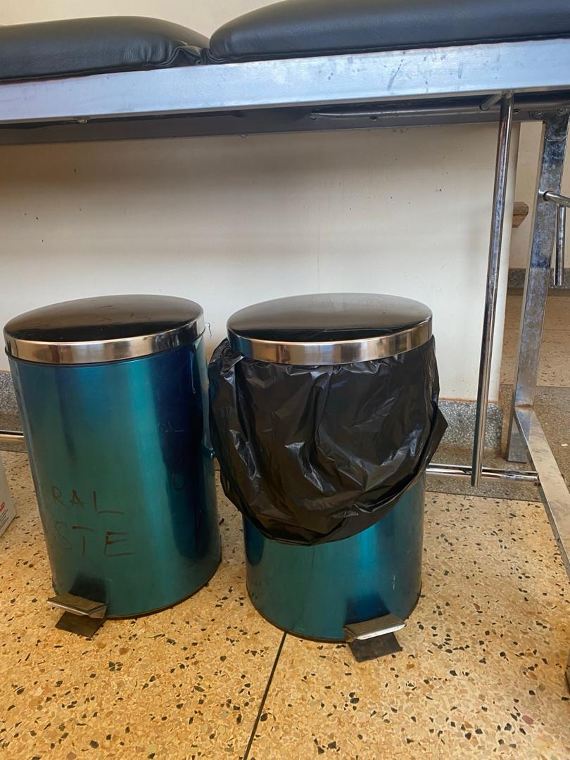
19 | Patient trolley with an adjustable backrest, fold- down safety side rails and hydraulic height adjustment mechanism | 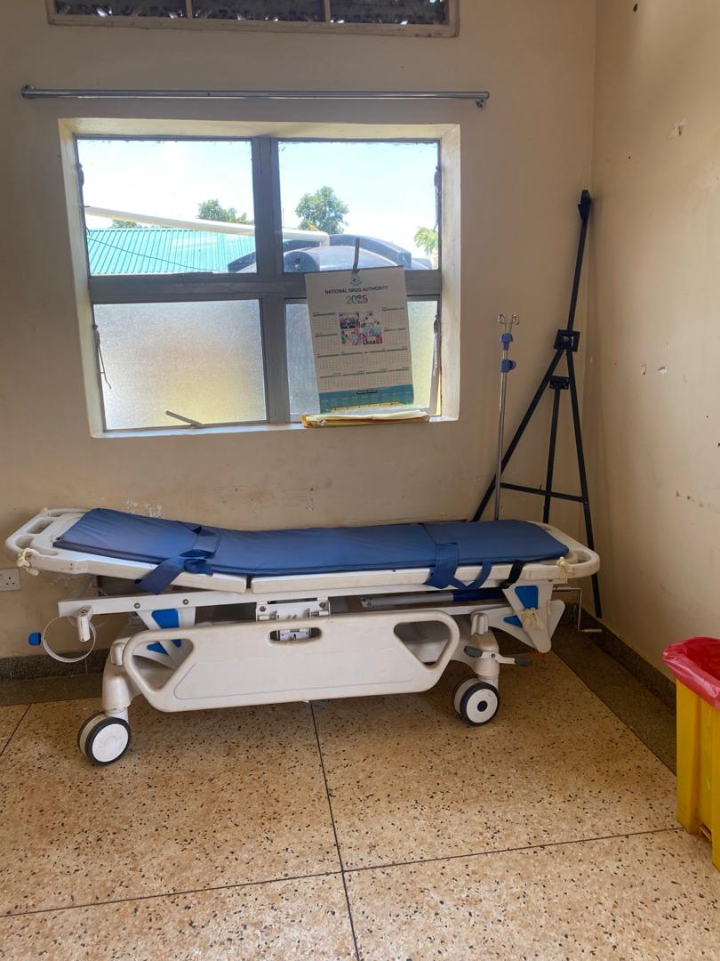
20 | Laboratory centrifuge with a circular specimen chamber, hinged lid and front control panel place in laboratory section. Equipment not engraved. | 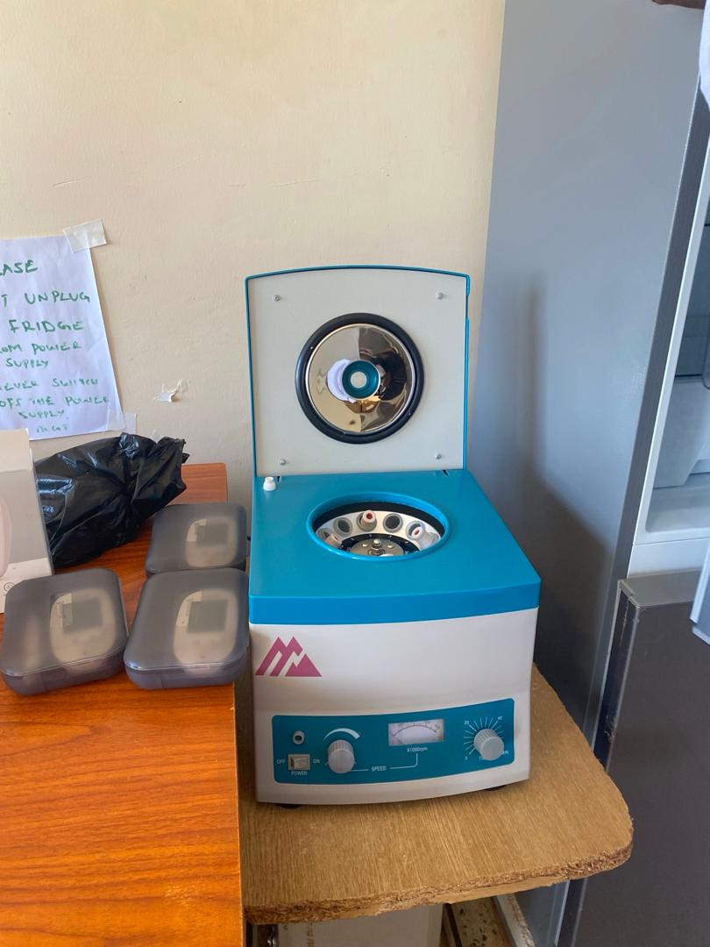
21 | A basic refrigerator with 2 layers placed in the laboratory | 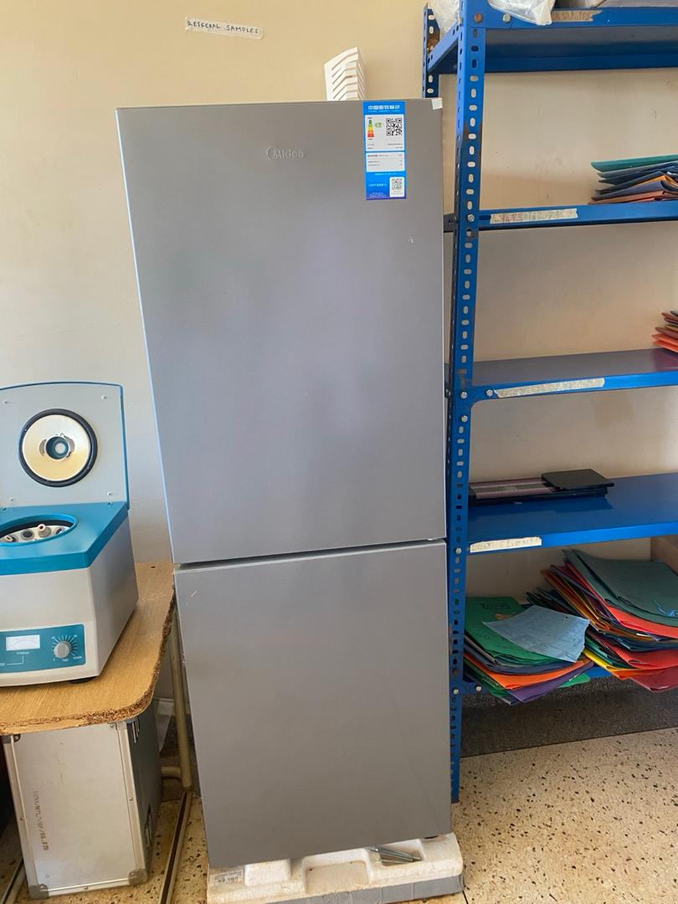
22 | Pediatric admission beds with mattresses attachments of drip stands | 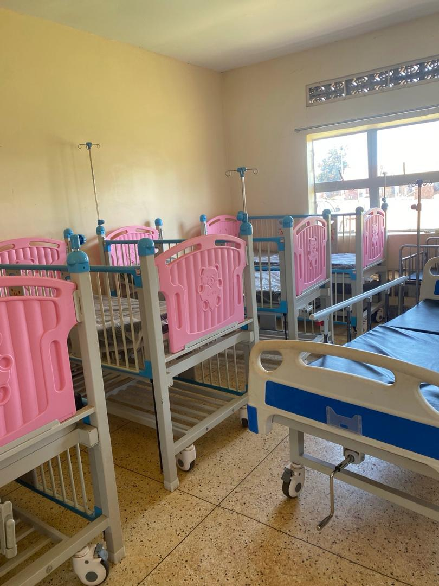
23 | Adult admission beds with mattresses | 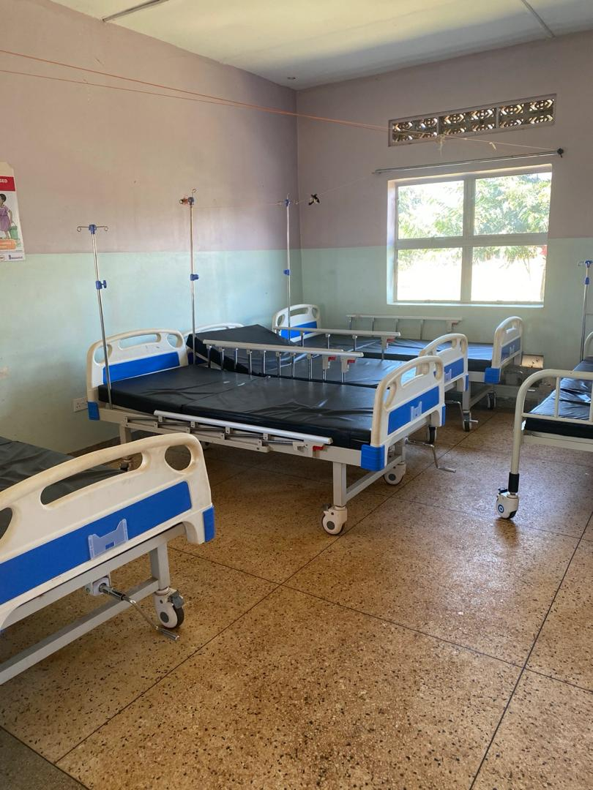
24 | Steel cupboard in the in-charge’s office. It is not engraved | 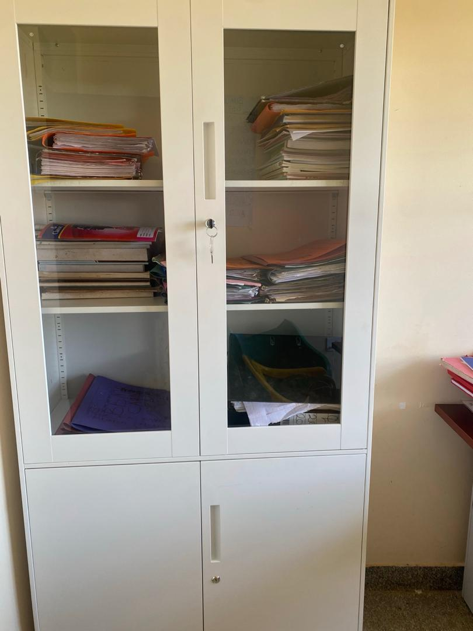
25 | An office chair and wooden desk with drawers | 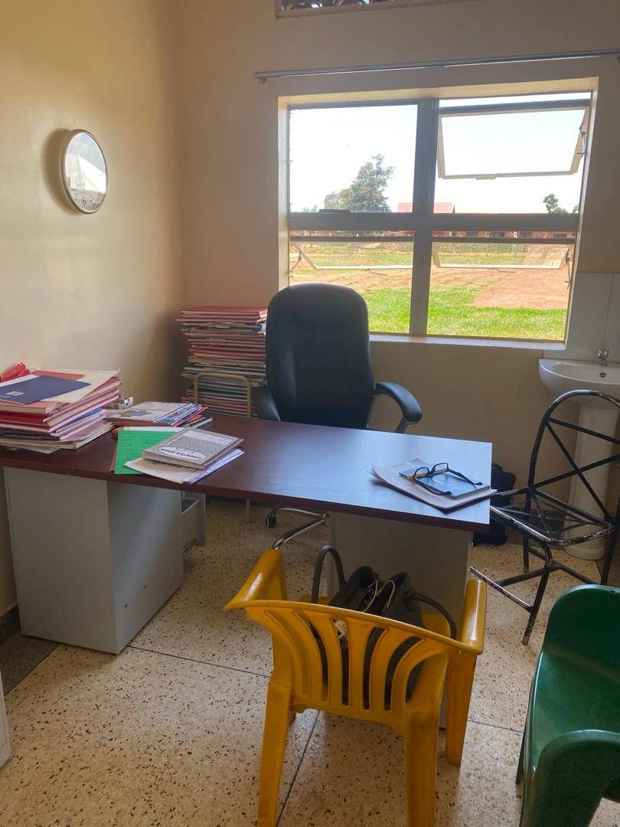
 | A stop watch and pulse oximeter. Each equipment is nonfunctional | 